FALEDO

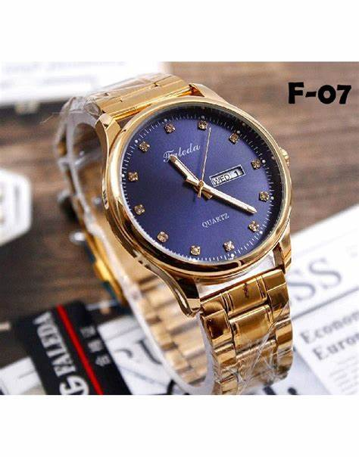DESCRIPTION: Faleda is a watch brand known for its stylish and functional timepieces, offering a blend of classic and contemporary designs. With a focus on quality craftsmanship, Faleda watches feature durable materials such as stainless steel cases, leather straps, and quartz movements for precise timekeeping. The brand offers a variety of models, including elegant analog watches and vintage-inspired pocket watches, catering to different preferences. Many Faleda watches also include practical features like date displays, water resistance, and luminous hands. Available through various online retailers, Faleda timepieces provide an affordable yet sophisticated option for those seeking both style and reliability